**CREATE ANDROID VIRTUAL DEVICE**

1. Open AVD Manager:

* Tools 🡪 Device Manager.

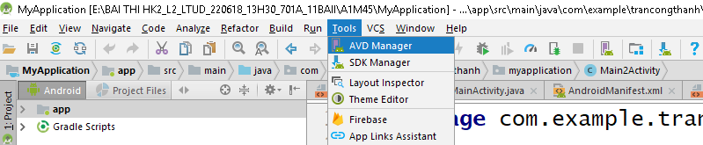

1. AVD Manager

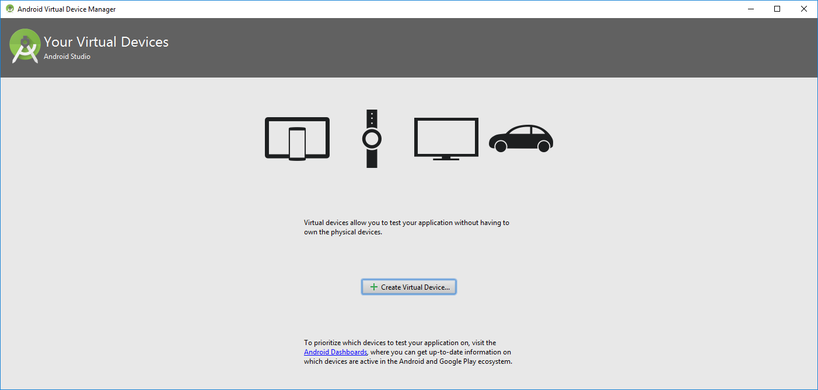

1. Create Virtual Device….

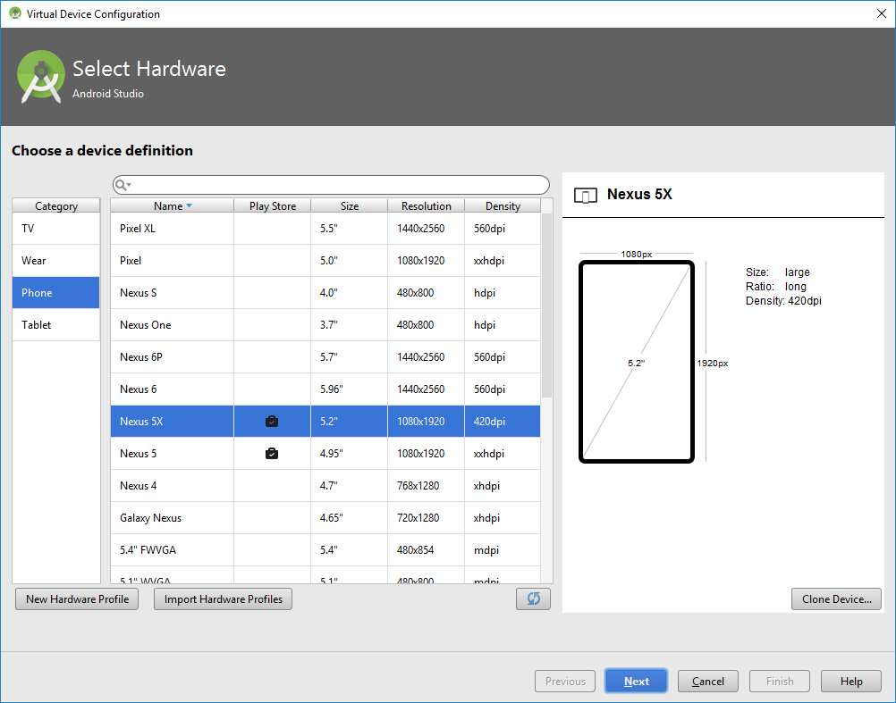

1. Select device : Phone, Tablet, Wear, TV..
2. Select configuration screen device: default device ( some popular device), customize (*New Hardware Profile*), edit default device ( *Clone Device*….)
3. Install SDK

Tools/Android/SDK Manager

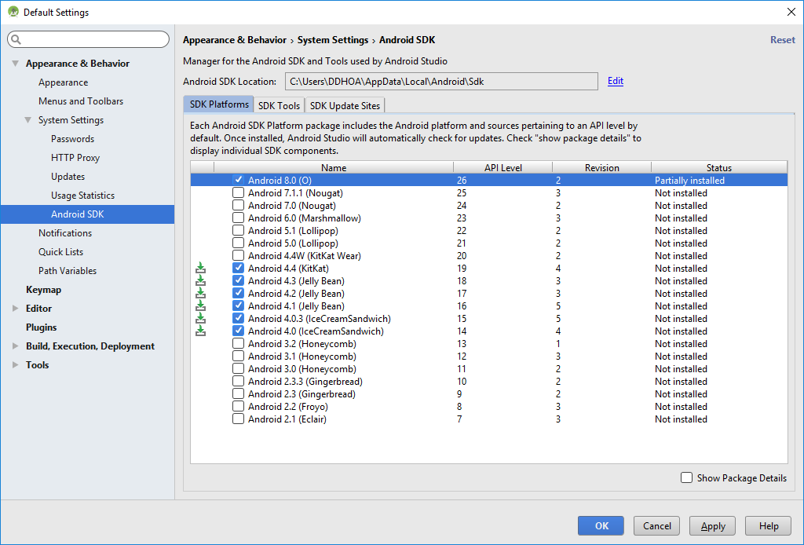

1. Next 🡪 Select configuration hardware, OS
   1. Amrabi
   2. X86/ x86_64 (intel) some PC not run this virtual device

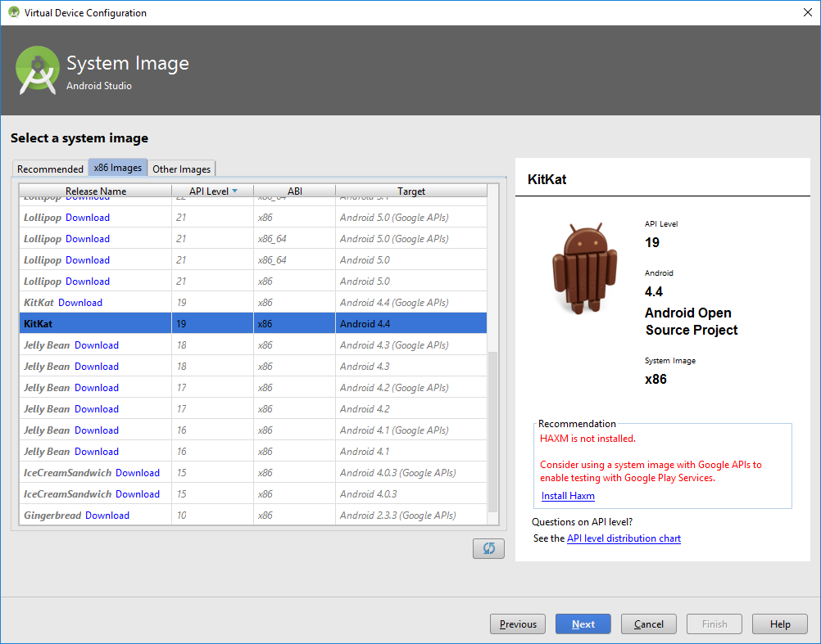

1. Next 🡪 Name Device 🡪 Finish

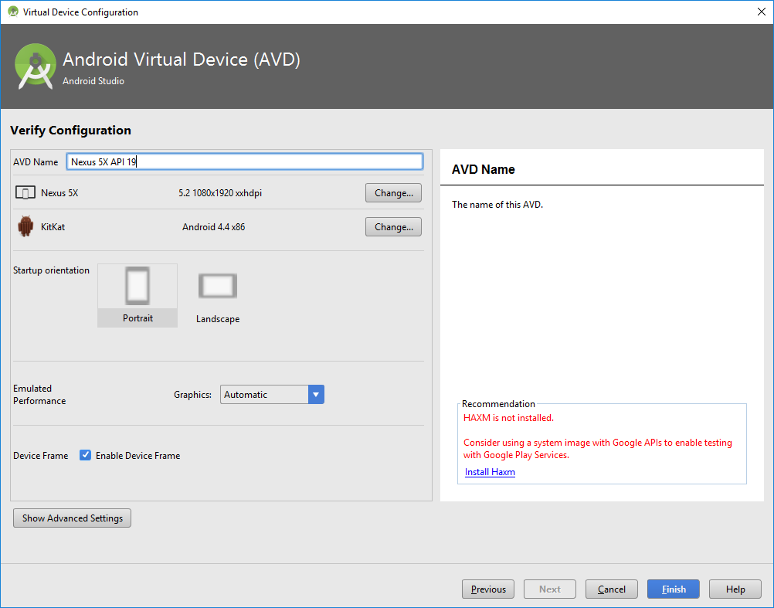

1. On disk:

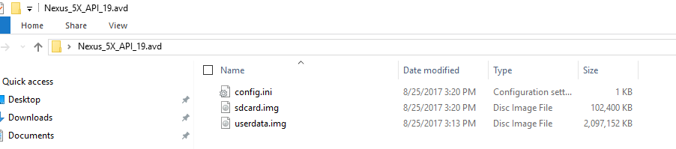

1. Run AVD

